Snowstorm as Meteorologists Nailed It: 02-13-2020

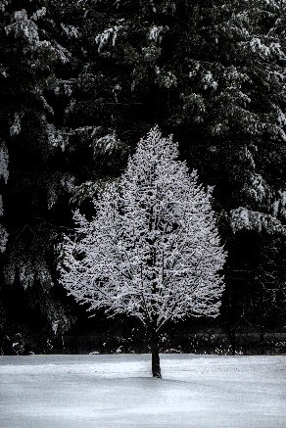

February 12th, the meterologists at Dark Sky and the Weather Channel advertised 3-5’ of snow overnight Wednesday and nearly 1” of rain on Thursday. They nailed it. We measured a clean 3” of snow on our driveway at 6 am Thursday. After breakfast, we took a walk around the land island behind our condo – a mile. Half-way along our walk, the city plow made his appearance as you can notice from the photos. Also included is a photo from 2/14 which shows all the snow removed from the trees behind our condo.   
  
And for the photos, click on [Snowstorm: 2-20](https://photos.app.goo.gl/hFnv49EcwQMaTG9i8). Feel free to “zoom”.